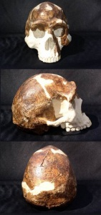
Skull #1 Homo sp. Heather Jones Anth-1030-48 PBR#1
1. No sagittal crest, rounded skull, increased cranium
2. Browridges-supraorbital torus
3. Face smaller, less prognathism
4.Smaller teeth, thinner enamel

Skull #2-Autralopithecine sp.
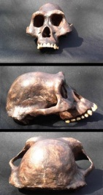
1. Skull narrows behind eyes with small cranium
2. Massive brow ridge
3. Subnasal prognathism
4. Medium sized canines
Skull #3- Homo sp.
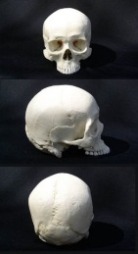
1.Back of cranium rounded, overall shift in cranium shape higher/rounded
2.Smaller brow ridges
3.Smaller nose cavity
4.Teeth and jaws smaller
Skull #4- Australopithecine sp.
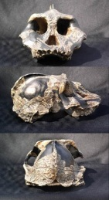
1.Small endocranial volume with sagittal crest, base of cranium flares
2.Massive brow ridge with broad flat face w/no forehead
3.Sagittal crest
4.No teeth to evaluate although upper jaw is rounded
Skull #5- Australopithecine sp.
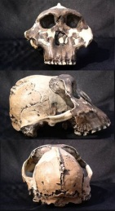
1.Increased endocranial volume, skull more rounded with minor sagittal crest, receding forehead
2.Questionable brow ridges
3.Smaller nose cavity
Skull #6-Early Homo sp.
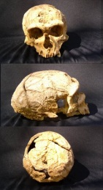
1.Increased endocranial volume, skull higher and more rounded, back of cranium rounded
2. Brow ridges
3.No forehead relative to moderns
Skull # 7 Homo sp.
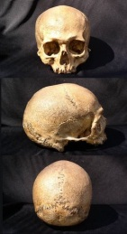
1.Increased endocranial volume, higher forehead, back of cranium rounded
2.Small brow ridges
3.Small nasal cavity
4.Smaller shorter mandibular ramus

Heather Jones ANTH-1030-48 PBR#1
Skull #8 Archaic homo sp.
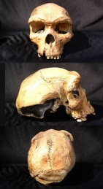
1.Increased endocranial volume, skull rounded, less forehead
2.Large brow ridges
3.Less prognathism
4.Smaller teeth

My empirical notes can be observed with each skull picture. I found that it is not easy to get a clear definition with some of the skulls because there are subtle differences from the morphologically broad definitions provided on the first skull lab worksheet.

For example Skulls #1, #6 and #8 are most probably Australopithecine. The brow ridges on all three and the flatter face on #8 make them seem to be more Australopithecine. It is hard to think of an ancestor to human species being more primate looking.

The most obvious skulls for me were the Homo sapiens #3 and #7, and the Australopithecines #4 and #5 . The sagittal crest on the two australopithecine skulls were obvious making them easy to determine. The Homo sp. skulls look like the typical skull seen on a lab human skeleton so they were easy to determine.

The eye sockets on all the skulls are varied. Skulls#2, 4, and 5 are higher on the head and closer together. This seems similar to how a primates eye sockets might be. They seem higher because there is no forehead. Also, the brow ridges are more prominent on these skulls. The progression to the more hominid skulls seems to be sockets moving further apart as brow ridges begin to diminish.

The two issues that seemed to me hard to justify were brow ridges and prognathism. It seems possible that the positioning of the skulls makes it look as if prognathism is present when it is not. The skulls that could be transitional from Australopithecus to Homo have various degrees of both. I have a hard time putting the traits into the Homo sp.

Teeth and oral structure on some of the skulls were harder to determine than others. The modern homo sp. is apparent but some of the older skulls with no teeth or very few teeth did not give me many clues to go on. The skulls with the sagittal crest suggest that there would be corresponding larger teeth on the jaw sides because the crest is where the chewing muscles would attach and the prominent crest suggests more/stronger chewing muscles but that is a guess.

On the first try at chronological order I had Australopithecus b. and Australopithecus a. in the wrong order but had the rest correctly listed. The difference between Homo n. and Homo h. are quite slight. In the lab of eight skulls I am not sure if there are both of these homo sp. I think that possibly skulls #1,#6 and #8 could be either Neanderthal or Heidelbergensis.

The tenets of evolution state that random variation and natural selection will cause an organism to progress to the most optimal state of existence. We inherit those traits that are most likely to allow us to survive and reproduce to pass on those traits. As we can see by the skulls in our lab there is a an obvious progression of brain size determined by the cranial cavity. We can also see the change in teeth and the structure of the mouth. Also the eye orbits changed in size over time. These changes have lead to a more intelligent being that can have control over its environment. Its nutritional intake has changed from strictly vegetarian to an omnivore that can make use of available food. Vision is more directed and capable of a wider view of the world.

This exercise was challenging and fun. It would be interesting to do a hands-on lab. I can see how the process of determining information from skull parts has evolved over time and with more and more specimens being found it is not always easy to put those specimens into a niche on the time spectrum. Because I support evolution I can justify having an ancestor that obviously has roots in the far distant primate past. For creationist thinking people it might be just as easy to say some of the skulls are apes and some are human, which is sad because it limits their understanding of how we developed into the people of the 21st century.

